**ASSIGNMENT 2 FRONT SHEET**

|  |  |  |  |
| --- | --- | --- | --- |
| **Qualification** | **BTEC Level 5 HND Diploma in Computing** | | |
| **Unit number and title** | Unit 16: Cloud Computing | | |
| **Submission date** |  | **Date Received 1st submission** |  |
| **Re-submission Date** |  | **Date Received 2nd submission** |  |
| **Student Name** | Bùi Hương Linh | **Student ID** | GBH200662 |
| **Class** | GCH1002 | **Assessor name** |  |
| **Student declaration**  I certify that the assignment submission is entirely my own work and I fully understand the consequences of plagiarism. I understand that making a false declaration is a form of malpractice. | | | |
|  |  | **Student’s signature** | Linh |

**Grading grid**

|  |  |  |  |  |  |  |  |
| --- | --- | --- | --- | --- | --- | --- | --- |
| P5 | P6 | P7 | P8 | M3 | M4 | D2 | D3 |
|  |  |  |  |  |  |  |  |

|  |  |  |
| --- | --- | --- |
| **❒ Summative Feedback: ❒ Resubmission Feedback:** | | |
| **Grade:** | **Assessor Signature:** | **Date:** |
| **Internal Verifier’s Comments:** | | |
| **Signature & Date:** | | |

Table of Contents

Introduction 4

Task 1: Design 4

I. Overview Function 4

1. Use-case diagram 4

2. Website screen shots 4

II. Code implement and deploy process 7

1. Tools and framework 7

2. Deploy 9

3. Source code and website 18

Task 2: Security 19

I. Analyze the most common problems which arise in a Cloud Computing platform and discuss appropriate solutions to these problems 19

1. Public cloud 19

2. Private cloud 19

3. Hybrid cloud 19

II. Access the most common security issues in cloud environments 19

1. Organizational security risk 19

2. Physical security risk 19

3. Data security risk 20

Conclusion 20

References 21

# Introduction

In the previous report, we discussed some fundamental concepts of cloud computing. Today, we will implement a web application in the cloud based on the solution I provided in my previous report. MongoDB serves as the database for my Node.js web application. Render will be used to deploy these projects on the internet.

# Task 1: Design

1. Overview Function
2. Use-case diagram

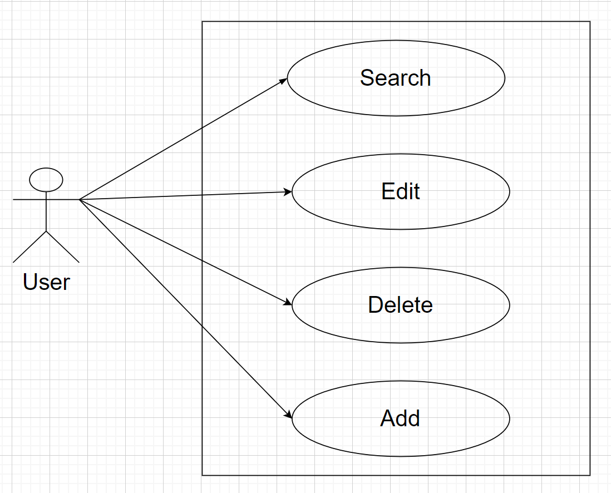

Web Application has the several function that are: Search – Edit - Add - Delete

1. Website screen shots
   1. Home page

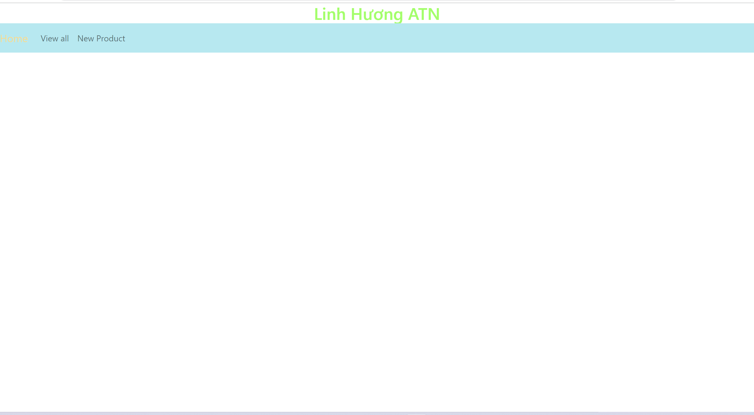

This is the first interface when using the website. It will show a navbar for menu list of function that includes store name, View all and New product.

* 1. View all

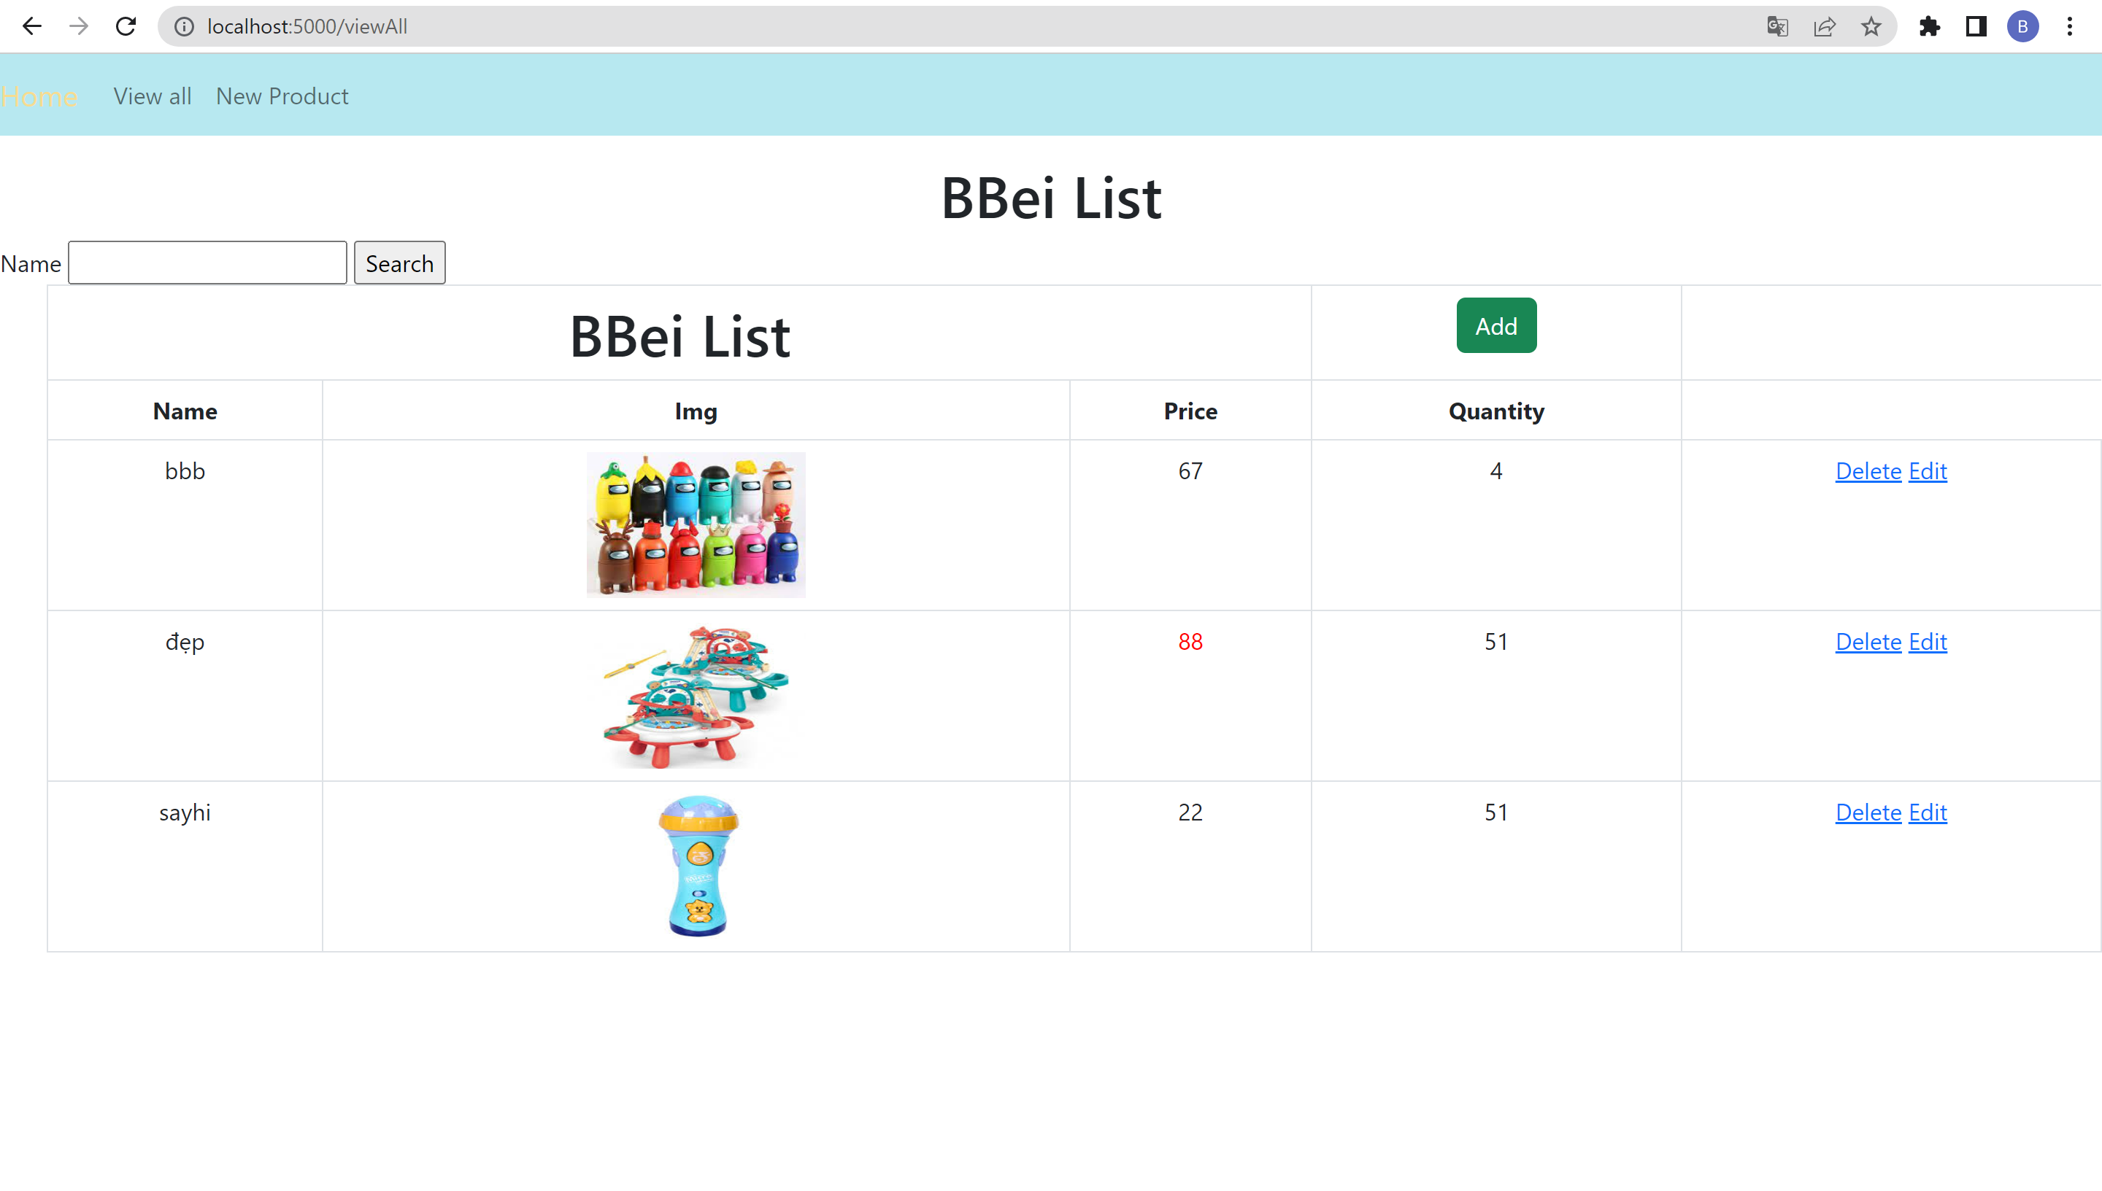

In this page I still have enough 3 interfaces: Home, View all, New product. At the main interface of this page, there is a table of 4 columns displaying full product information including: Name, Img, Price, Quantity and product search bar and 3 function buttons: Add, Edit, Delete.

* 1. Add new product

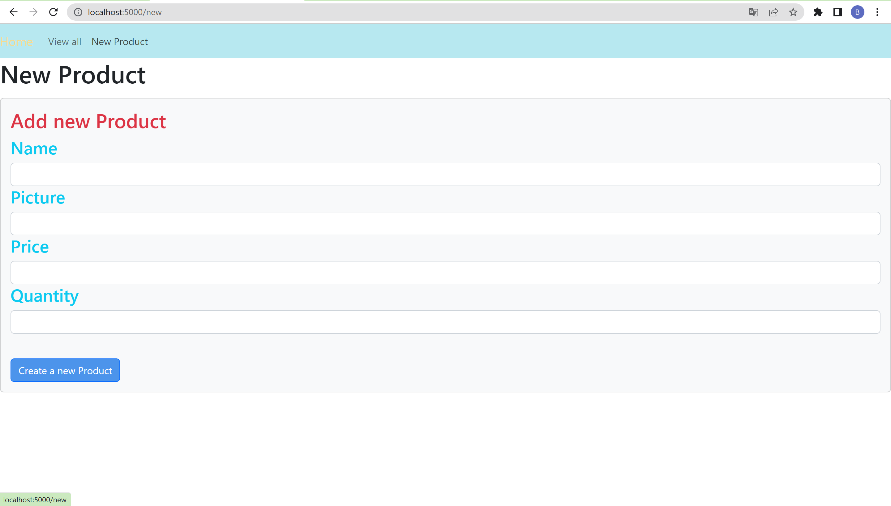

This page contains six new product information fields. You must complete all the information, if you do not fill in all the information, the "Please fill in this field" line will appear.

* 1. Edit product

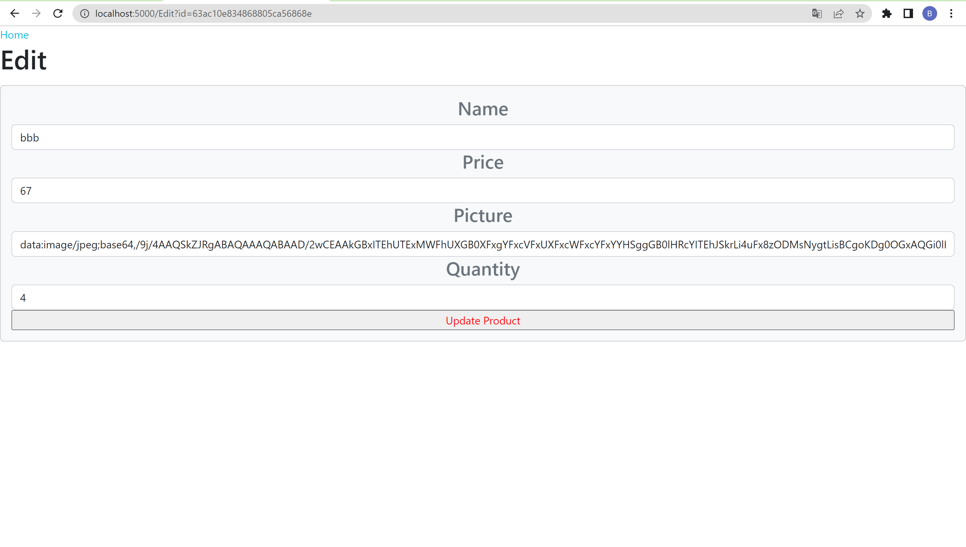

This view will appear when you click 'Edit' in the table under 'View all'. At this interface will display product information and users can update to suit their needs.

* 1. Delete product

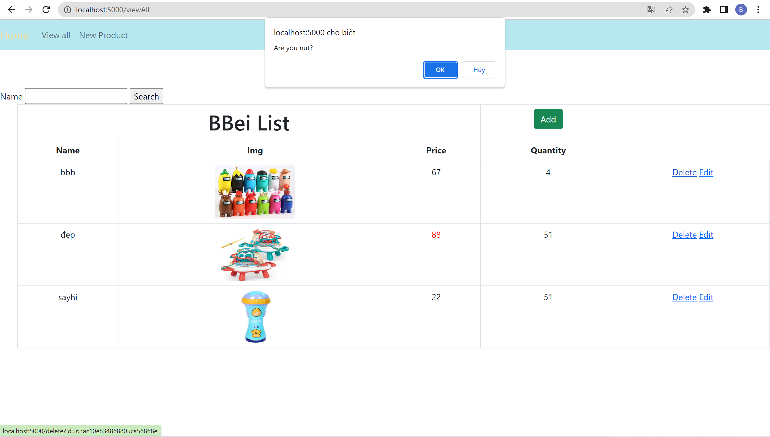

By clicking the erase button, you are asked to remove this product from the website. If you select "Ok," the item will be removed.

1. Code implement and deploy process
2. Tools and framework
   1. IDE

The advantages of using Visual Studio Code for this project are as follows: Starting is very simple and takes very little time. Many different programming languages, as well as numerous extensions, are supported. Visual Studio supports Git CLI terminal commands.

Code:

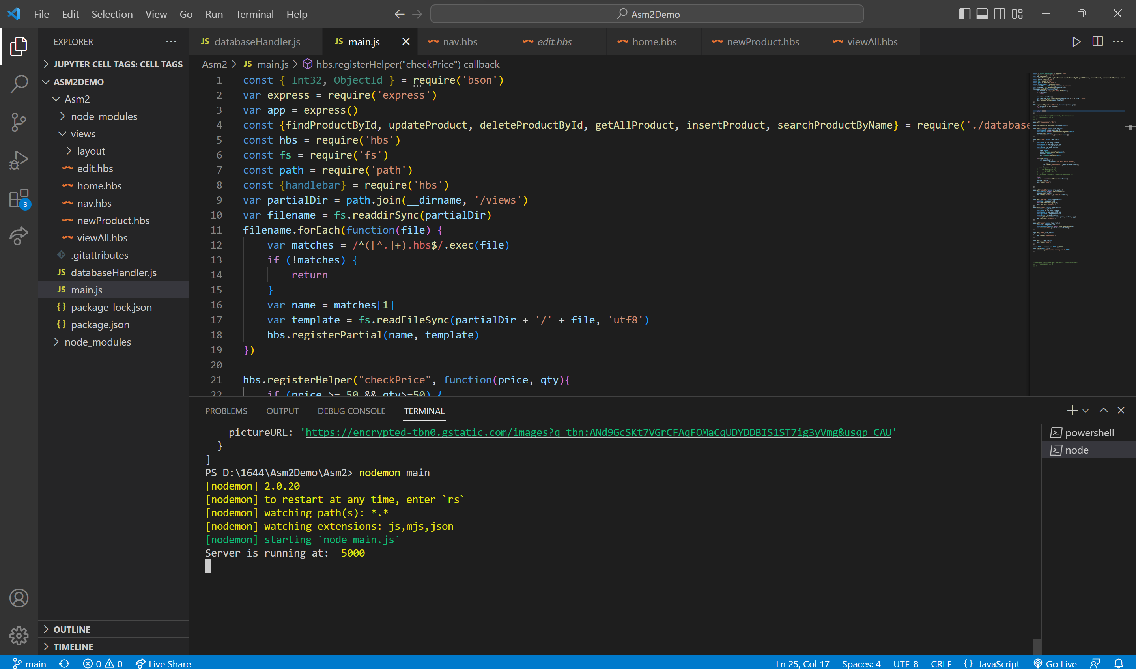

* 1. Framework

This project makes use of the Express framework. The name Express refers to a NodeJS framework. Its numerous powerful features can be used by both web platforms and mobile applications. Express supports middleware and HTTP technologies, resulting in a highly dependable and user-friendly API. The following list summarizes Express's key components. Create an intermediate-level class that can respond to HTTP requests. Describes routers that can be used for a variety of HTTP and URL-based tasks. An HTML page may be returned based on your input.

* 1. Source code manager

Using GitHub will allow me to manage and communicate source code with other project team members more easily. It also makes backup and storage of source code easier.

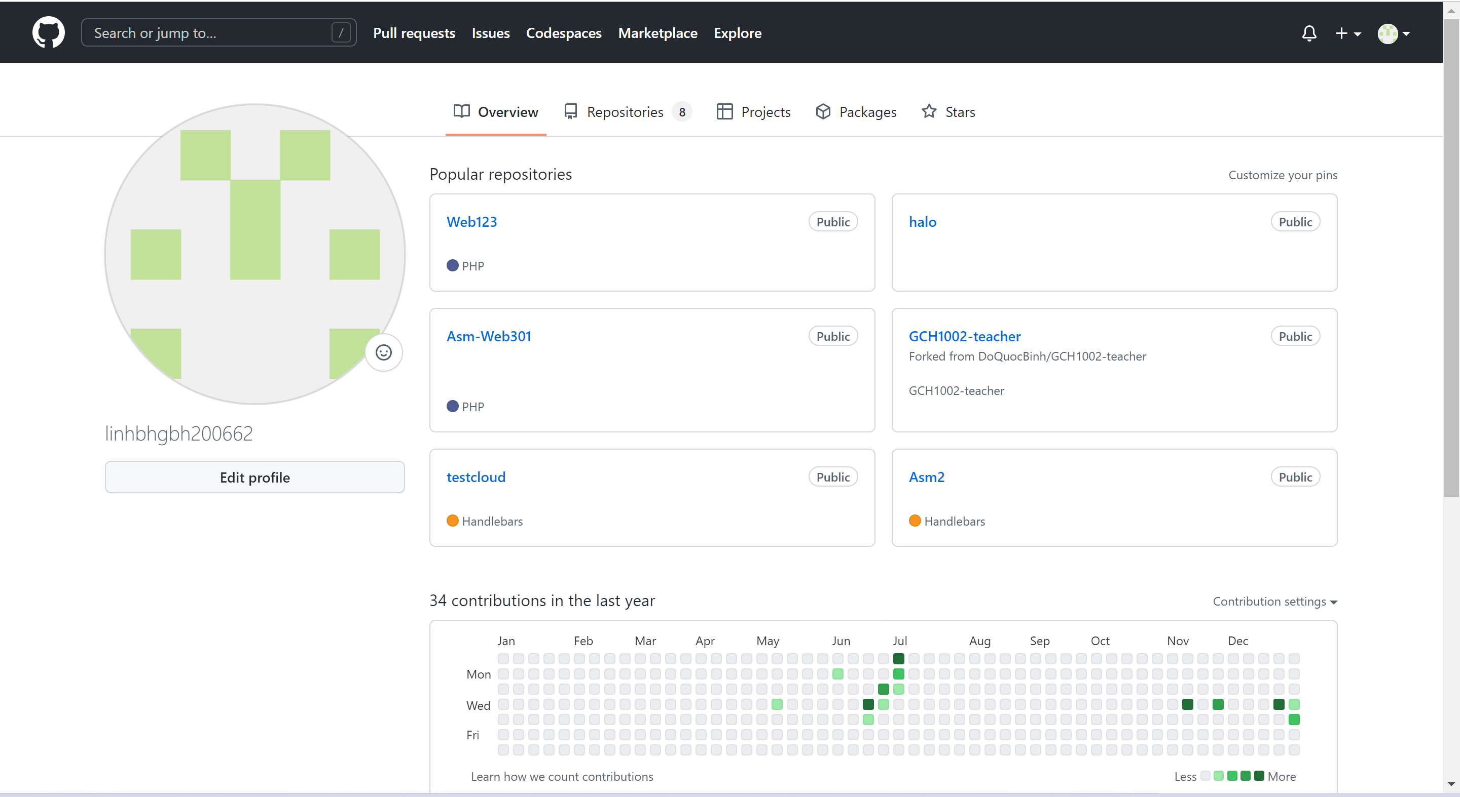

* 1. Database server

Because it allows online databases and only requires a MongoDB account and mongo settings, I chose mongodb as the database for the Atlas project to obtain a connection link. Documents are retained in document-oriented storage with high security and are stored as JSON-formatted files. It’s noSQL database.

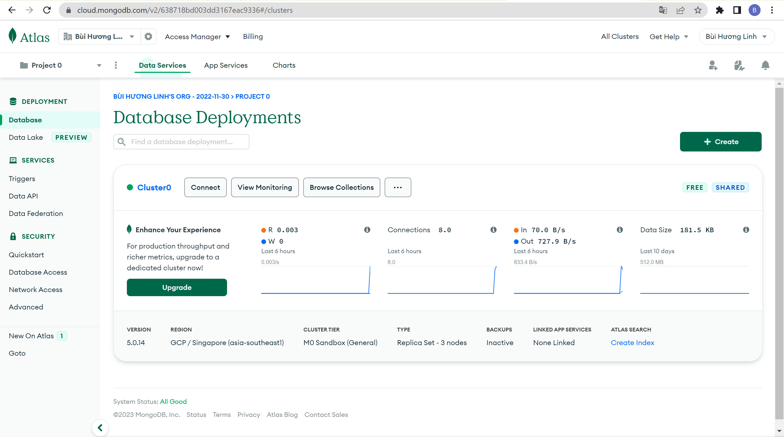

* 1. Cloud computing module

In the final stage, the app will be published to the internet via render. It has a wide range of applications and is appropriate for small to very large businesses. Render provides a capable technical team that is available 24/7 and adheres to a variety of security guidelines.

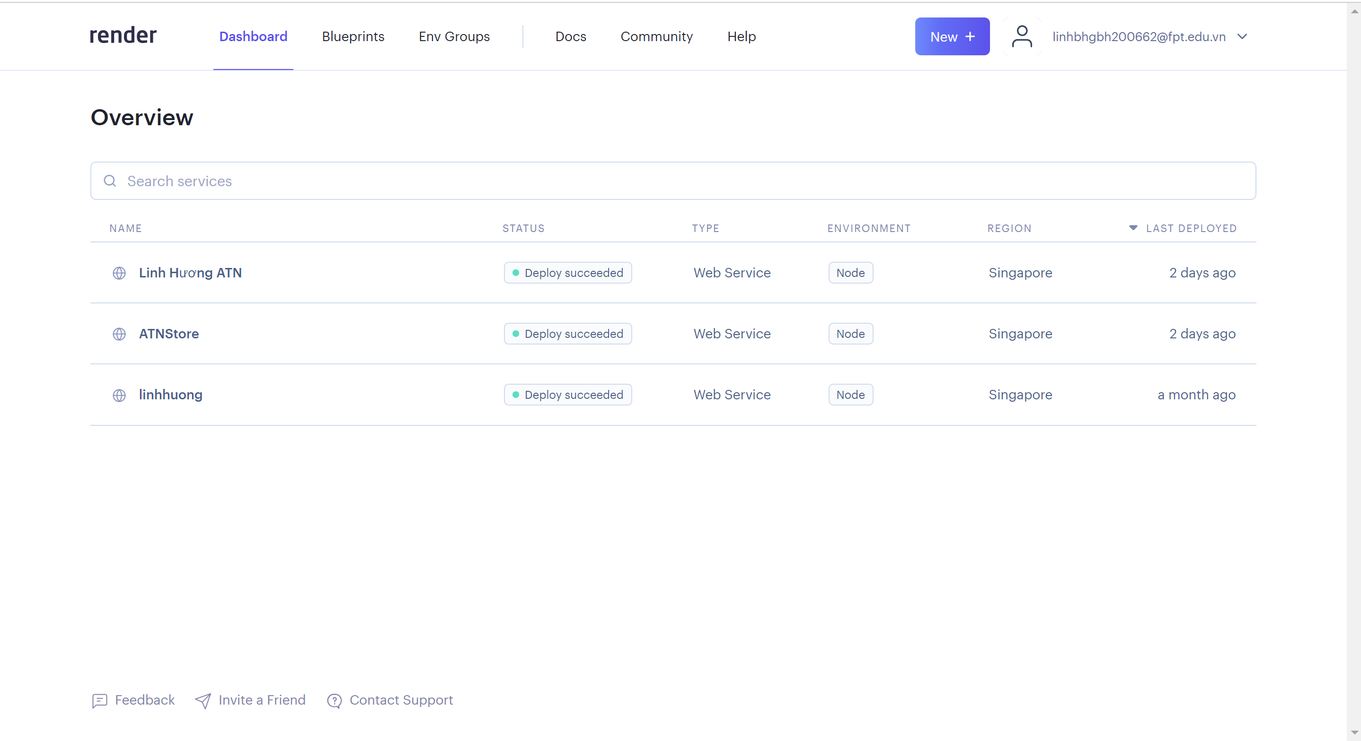

1. Deploy
   1. Config the framework on the env

Because Express is a nodejs framework, the first thing we need to do is download and install nodejs.

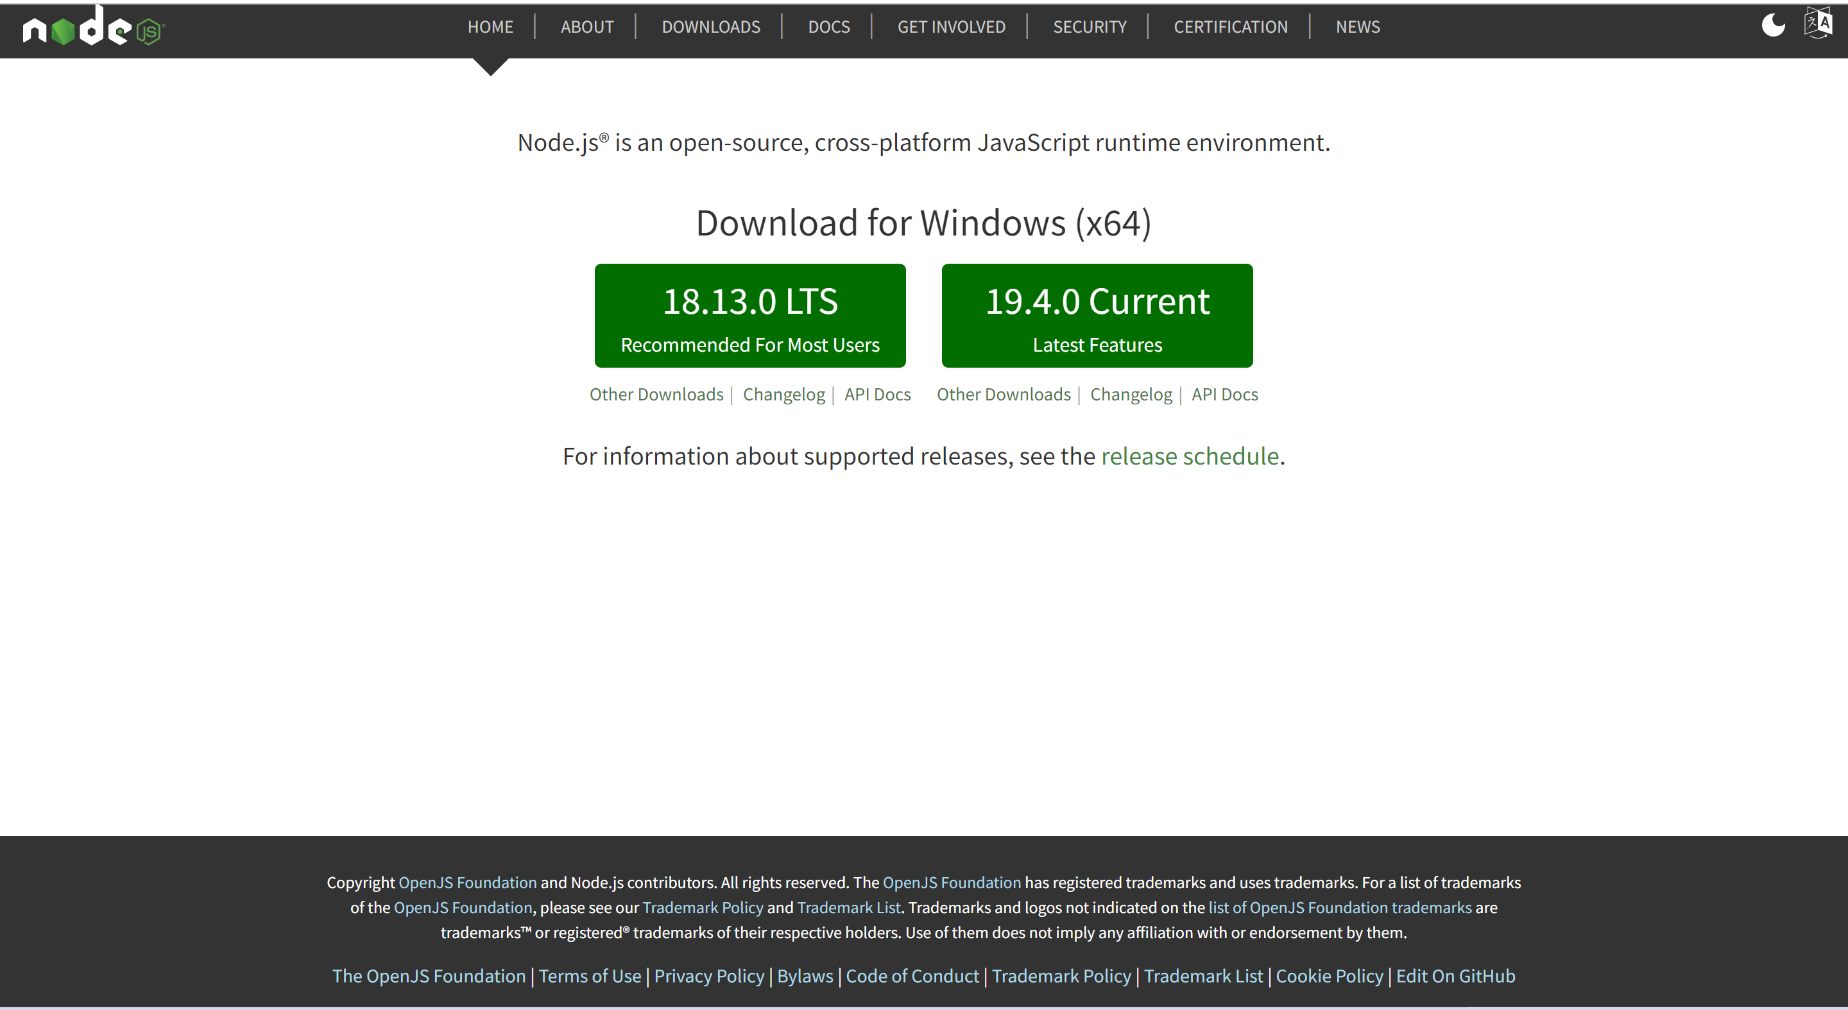

When the first stage is completed, create a project and use a terminal command to install express using the Node package manager: npm install express.

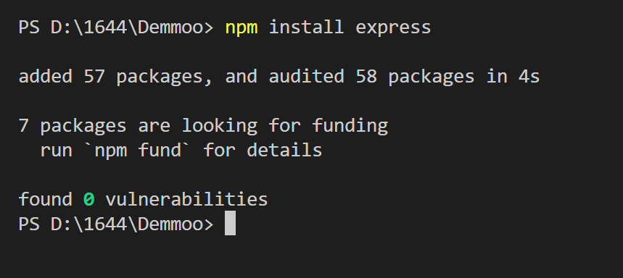

* 1. Config and connect to MongoDB

The next step is to connect to the database. We will use mongodb at the end of the project because it is more appropriate for the project than installing it locally. As a result, we must create a mongodb atlas account.

Create new cluster:

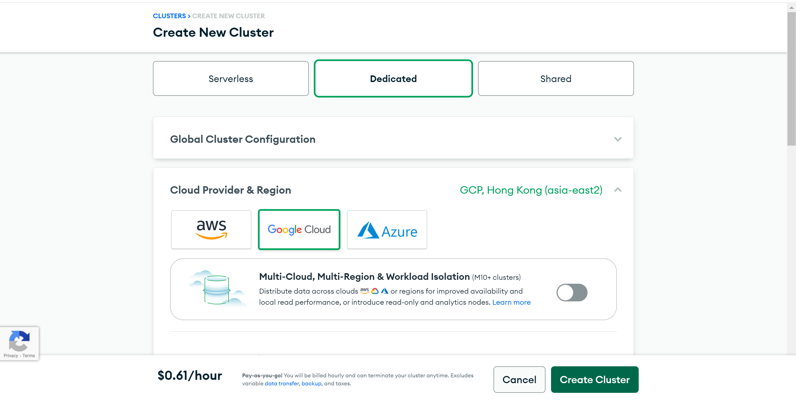

Add IP address:

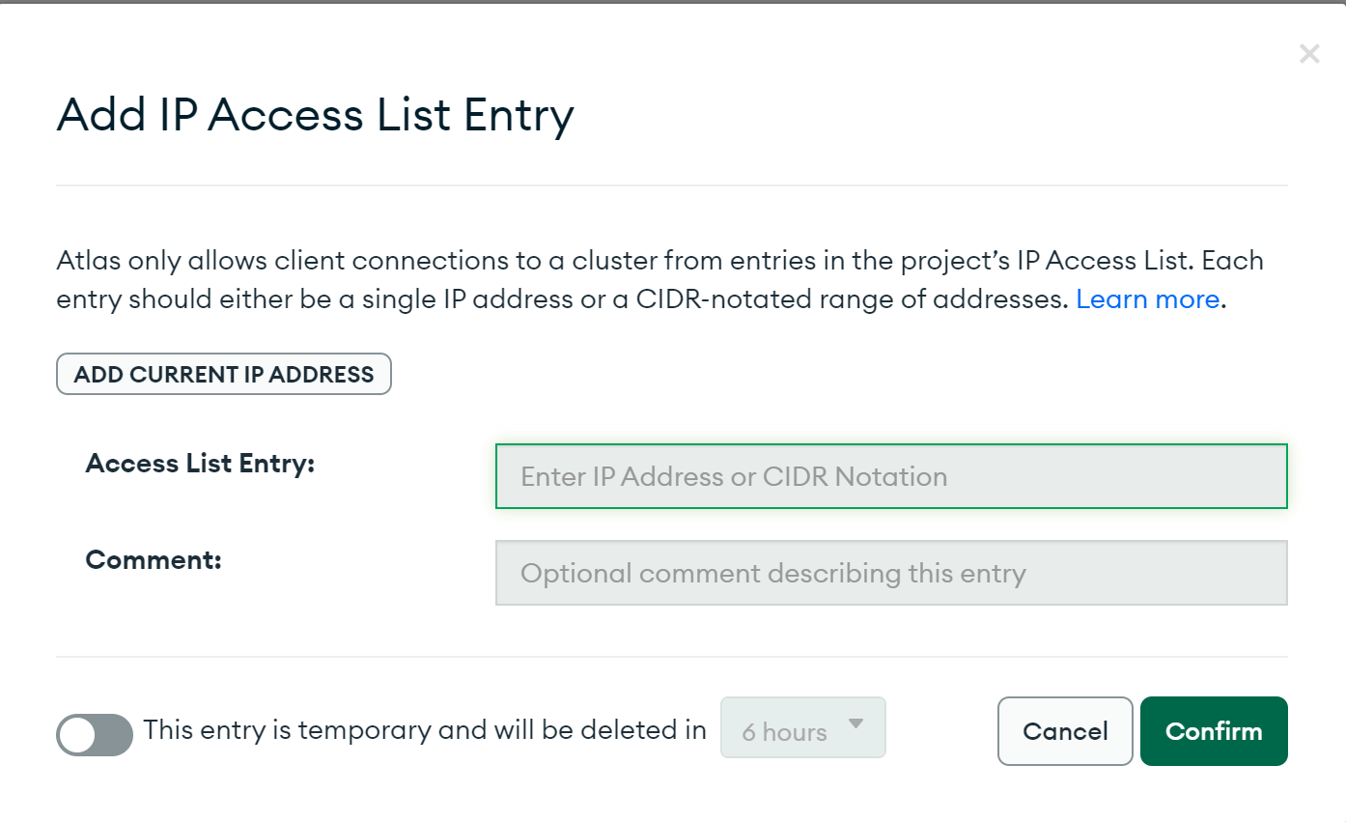

Create database:

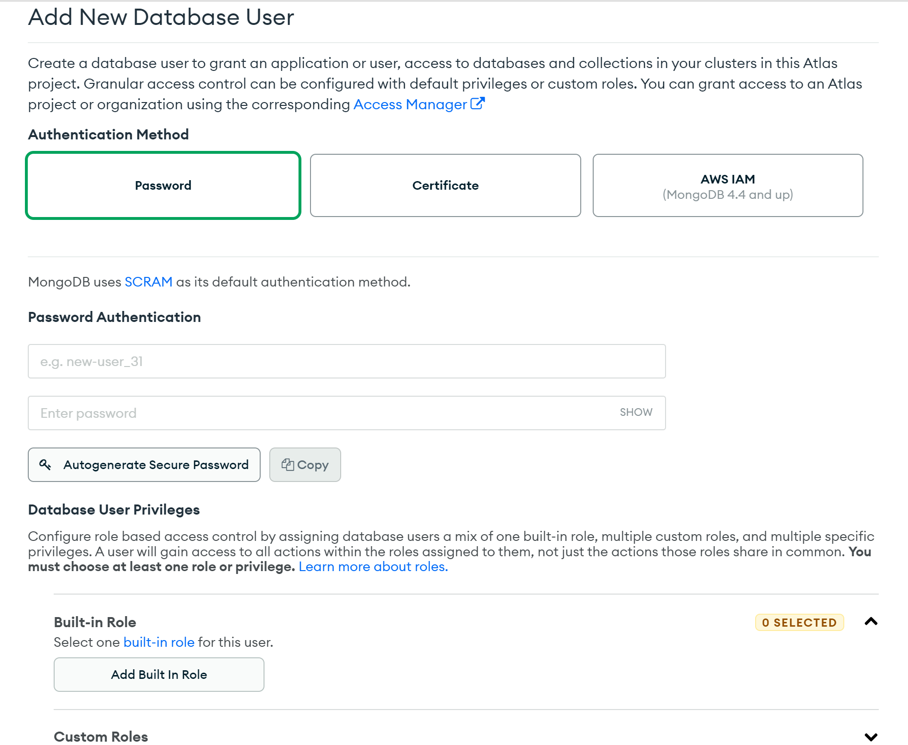

Get connect strings:

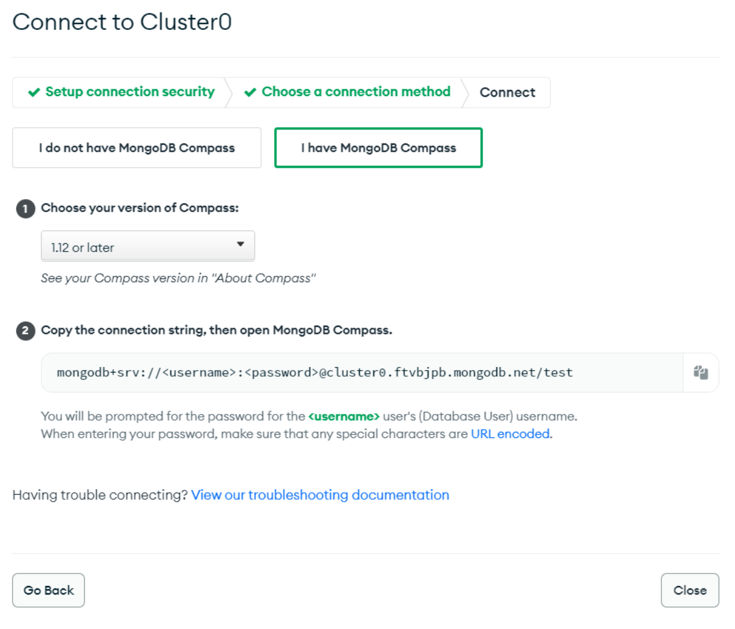

* 1. Config git and upload file to GitHub

While developing a web application, I must use Github to manage the source code, then push it to render for testing. I will build one repository to handle one repository for each project.

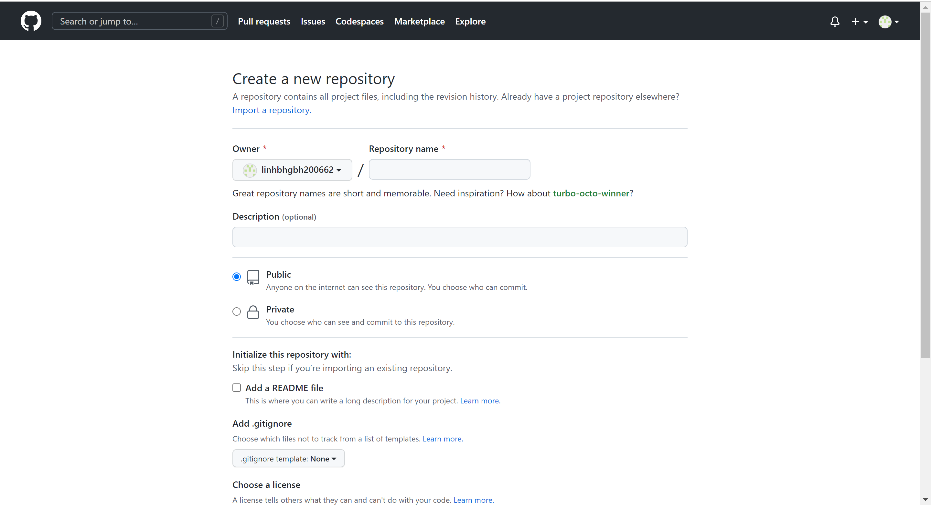

I'll start the command line after creating a repository so that we can run the program with git.

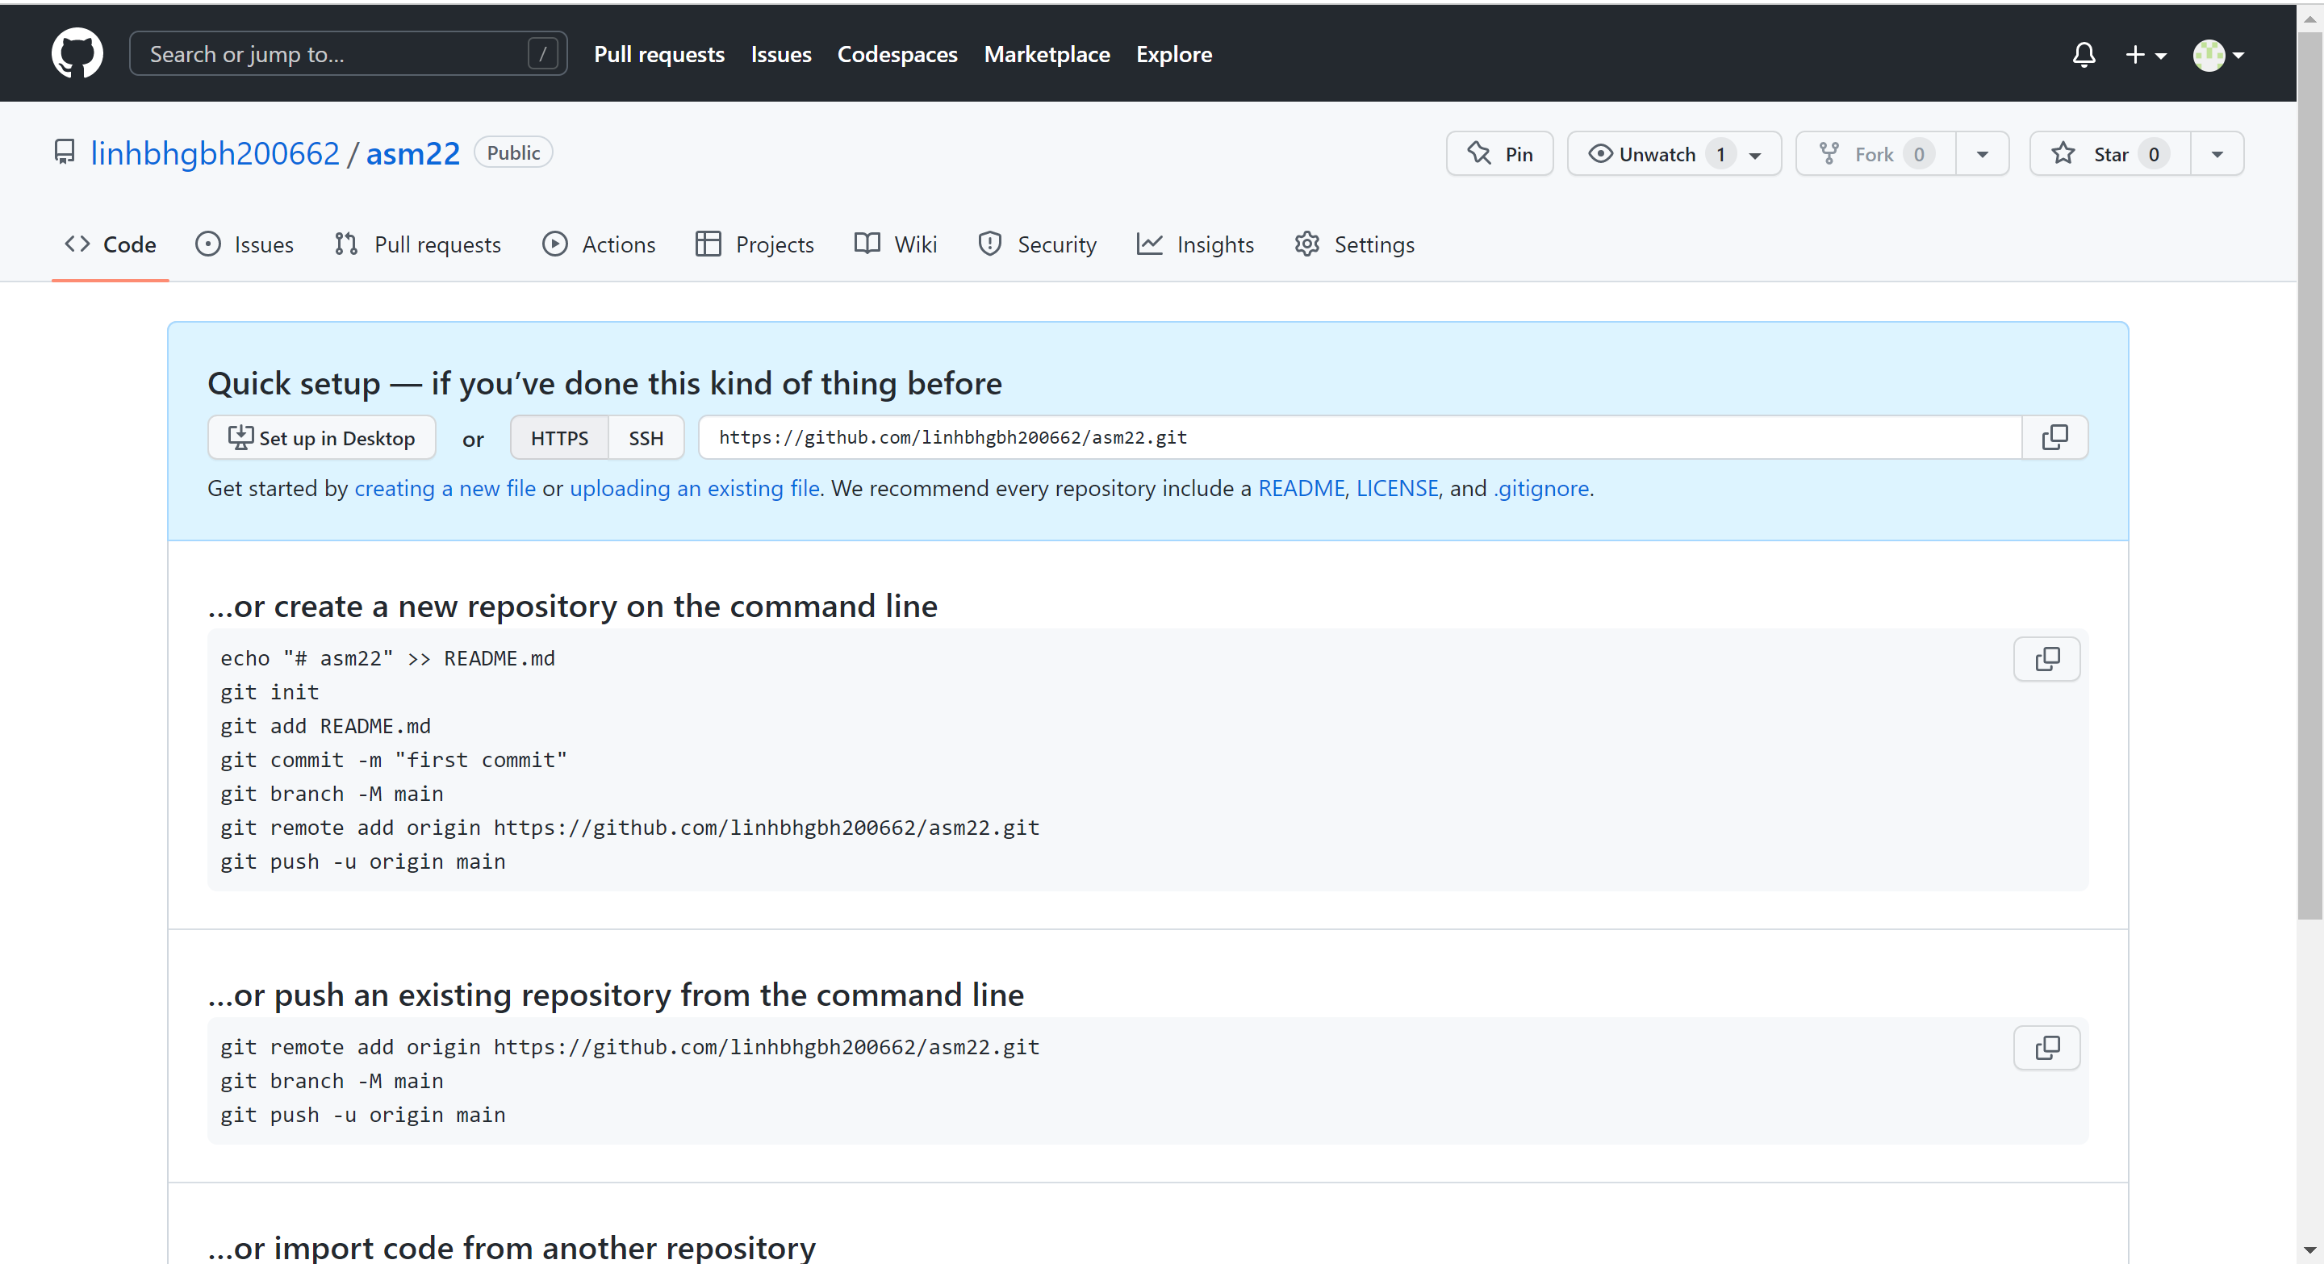

If the upload was successful, you can find the source code in your github repository.

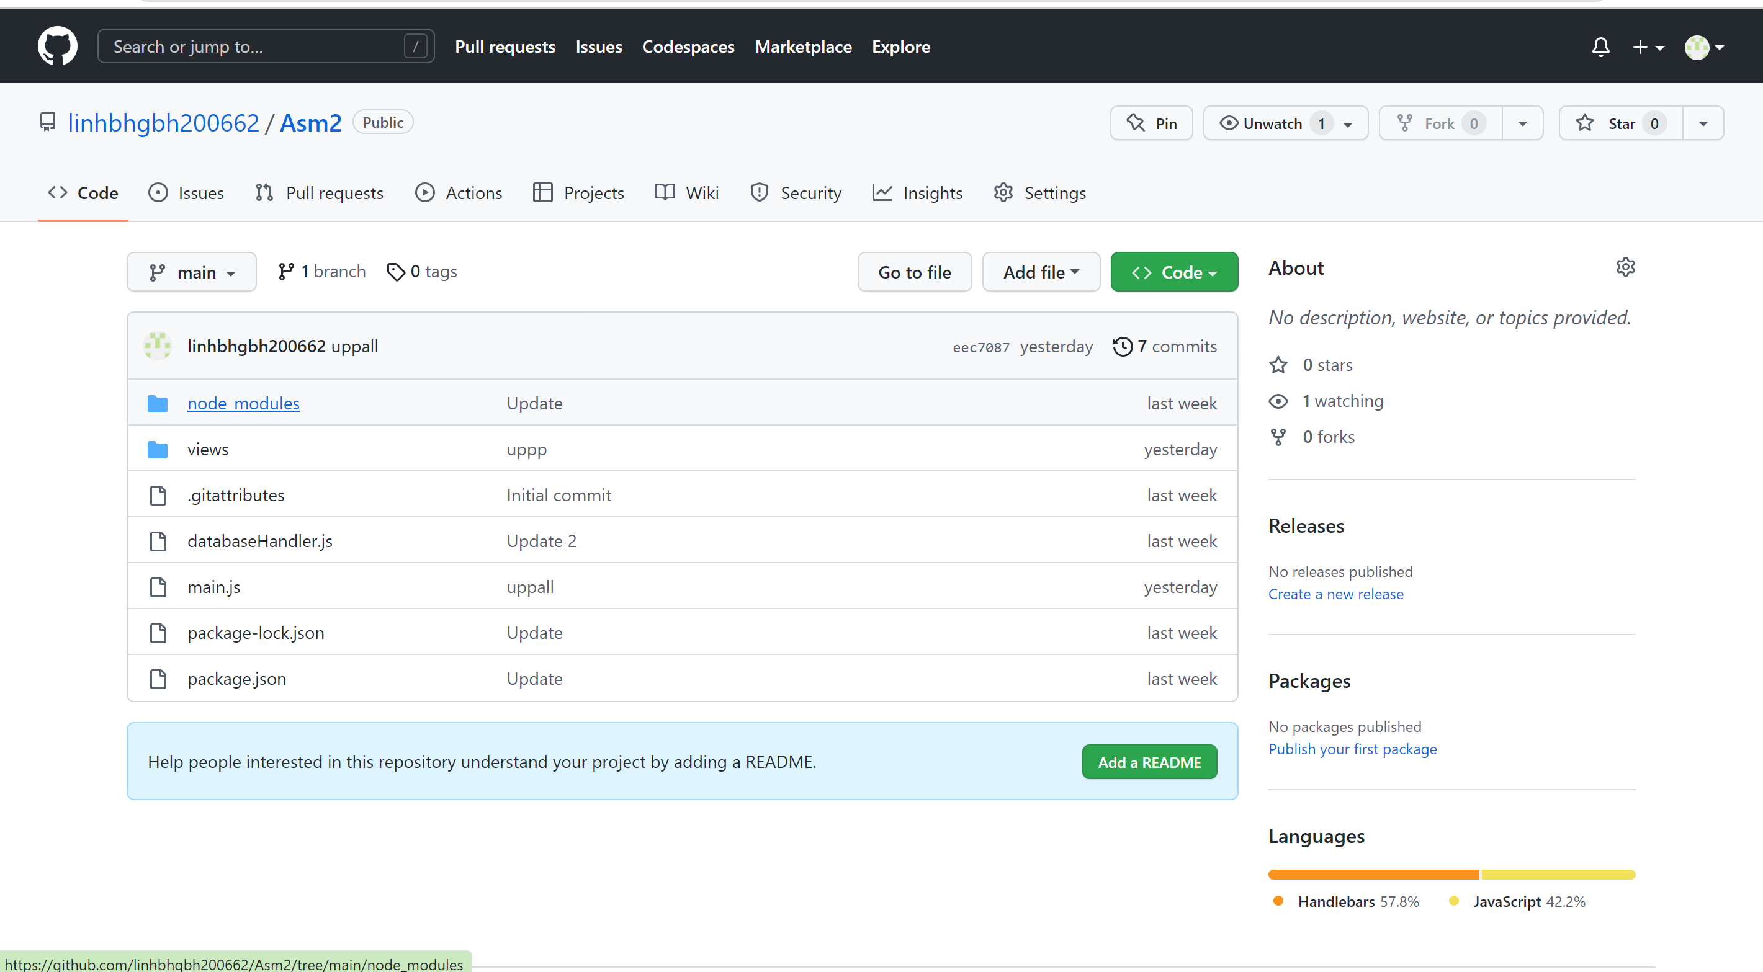

* 1. Deploy code on render server

First, we'll log in to render with our github account.

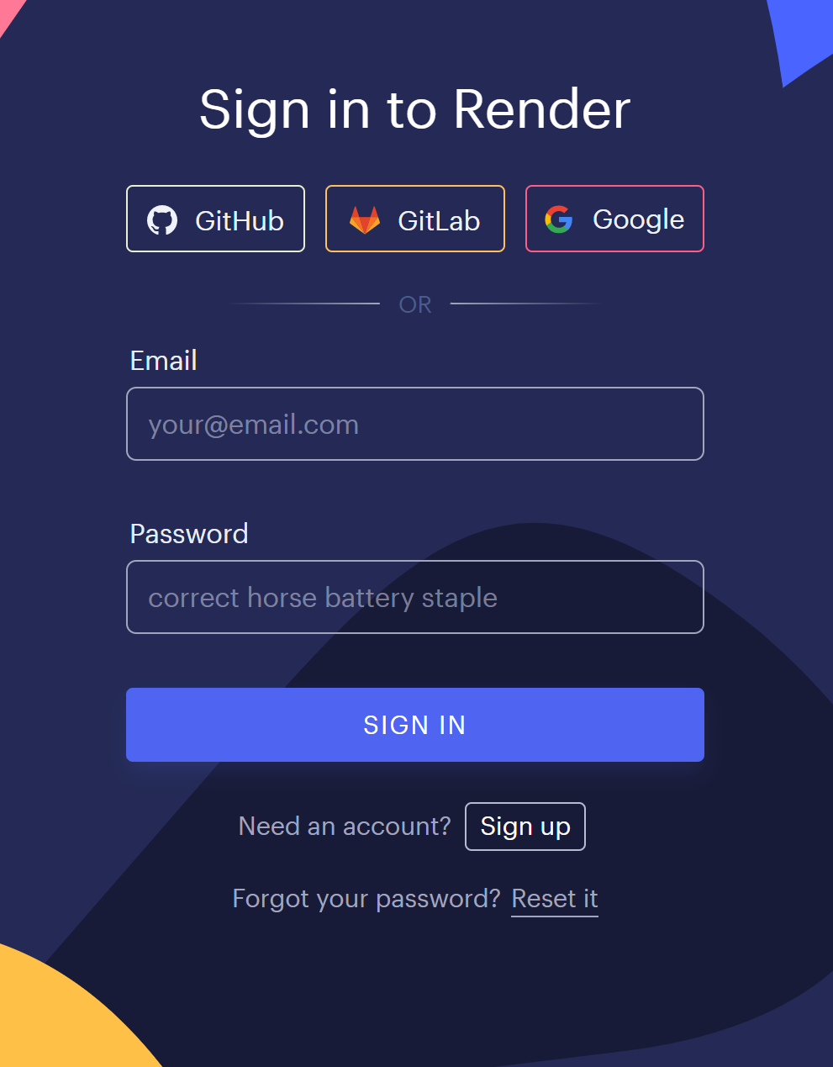

After logging in, the render's Homepage will look like this.

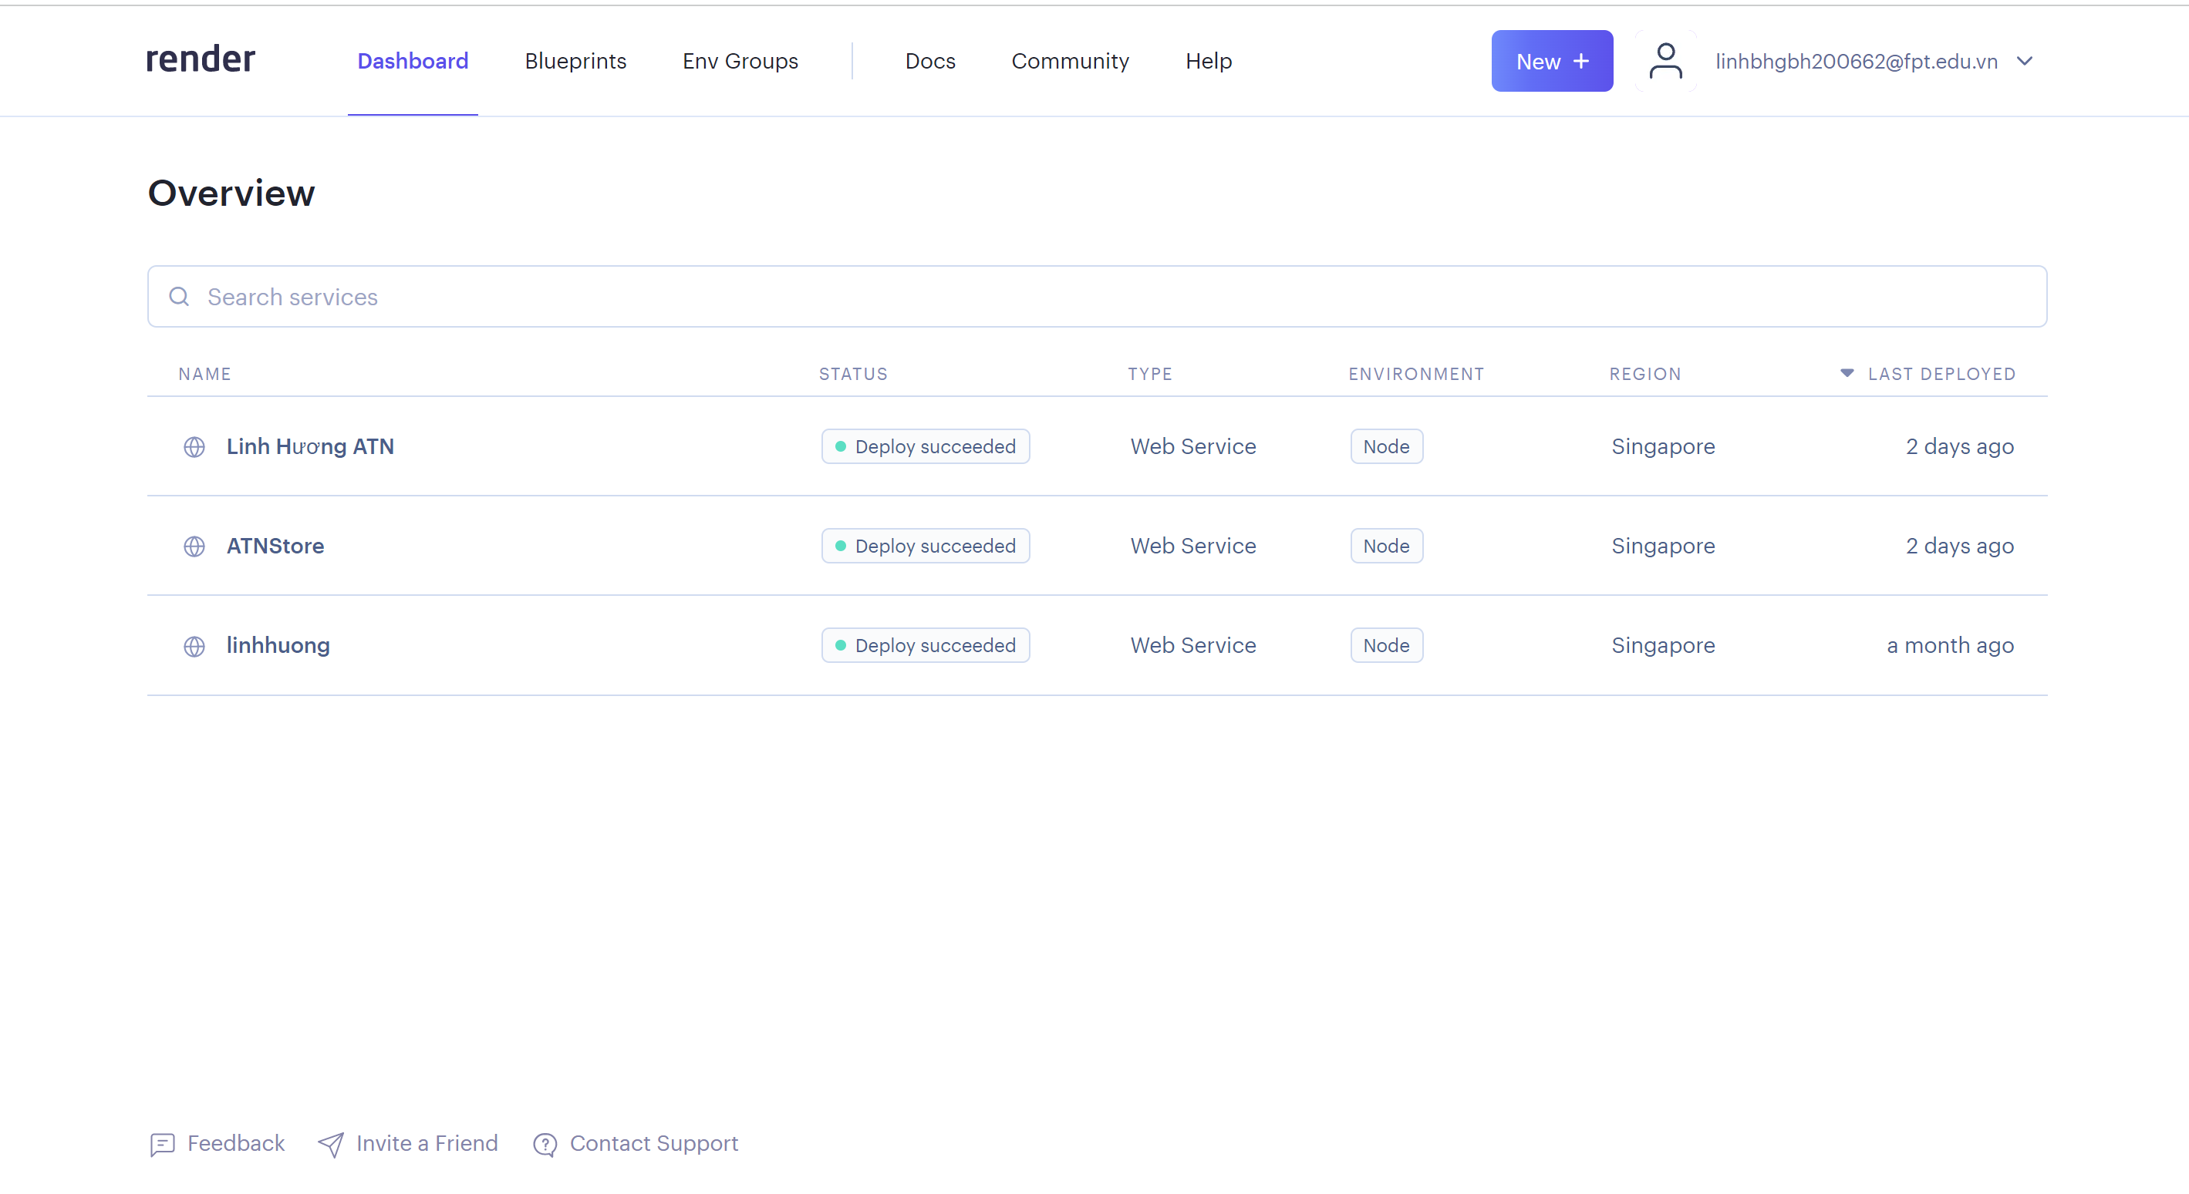

Then, to create a new website, click on new.

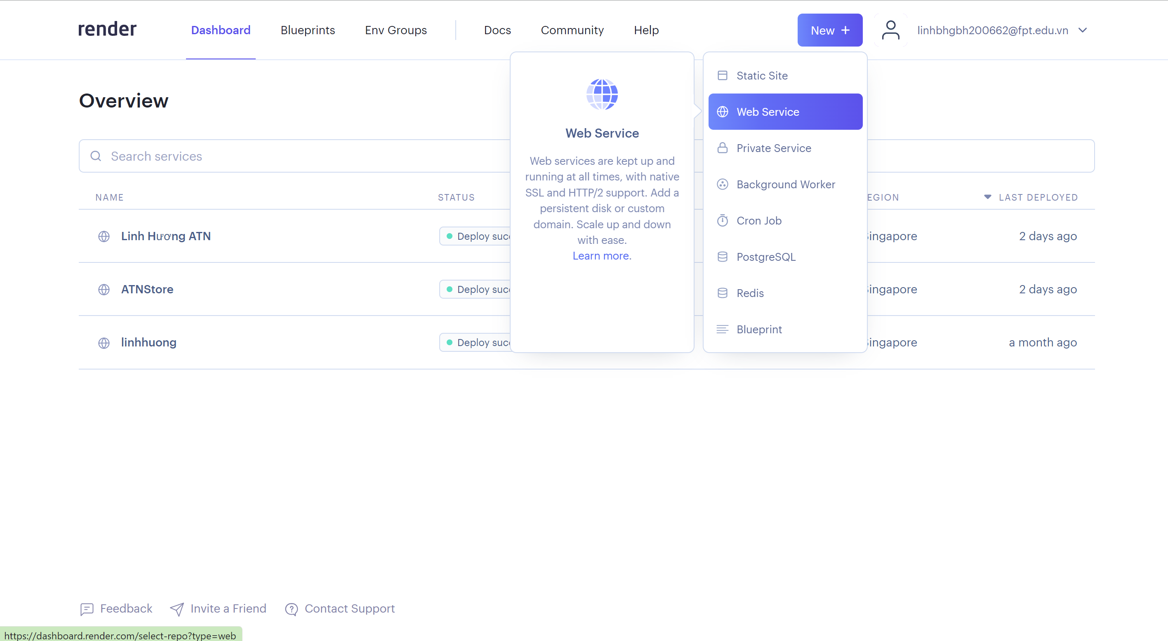

Then connect to the repositories listed above in github.

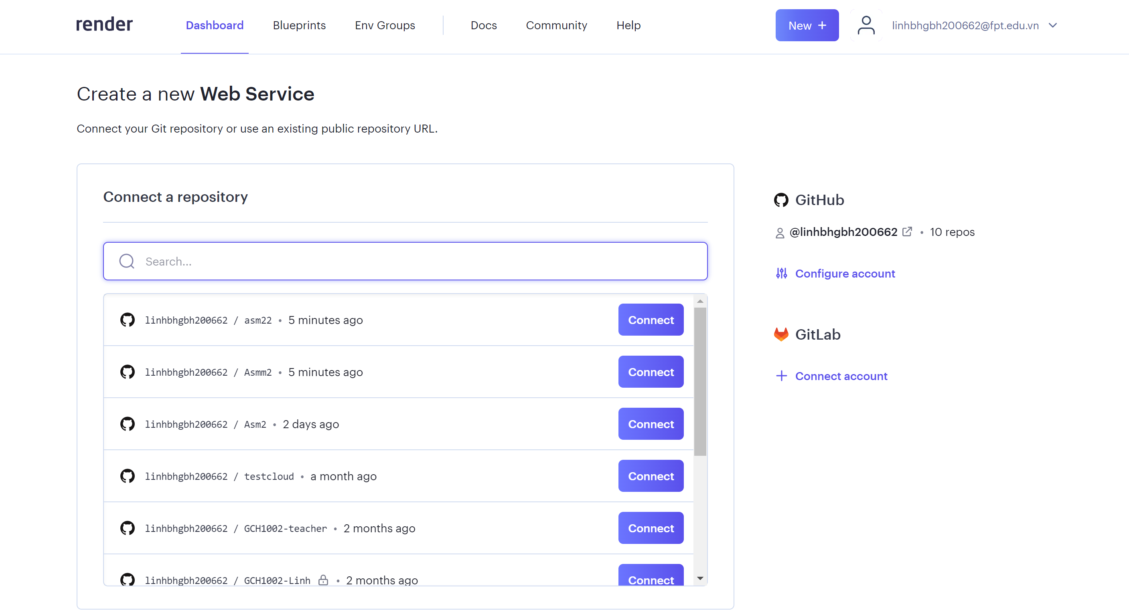

Then I'll name the site and change the region to Singapore, and the start command will enter the node plus the section where you'll run the program in Visual Studio Code.

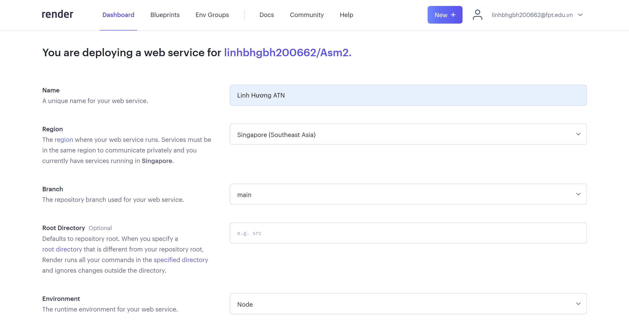

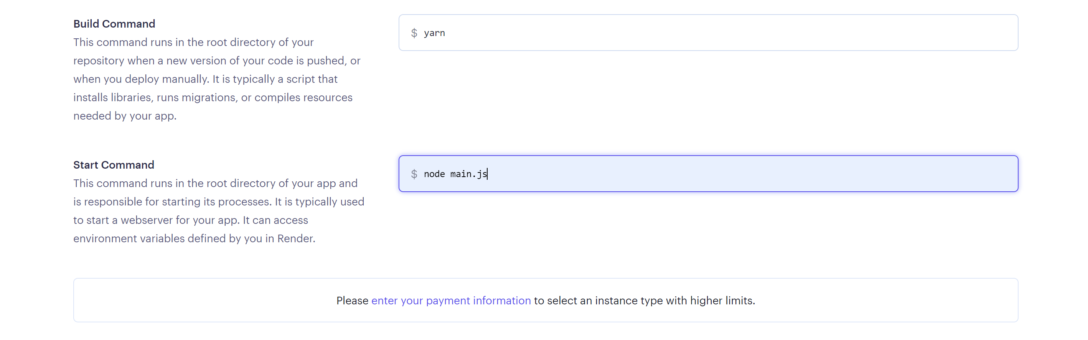

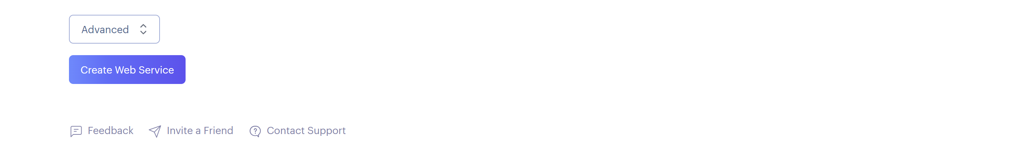

It will display a success screen with the words "Server is up" after it has finished running.

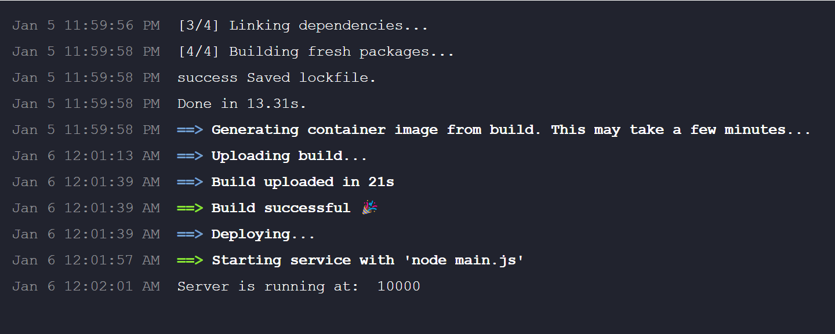

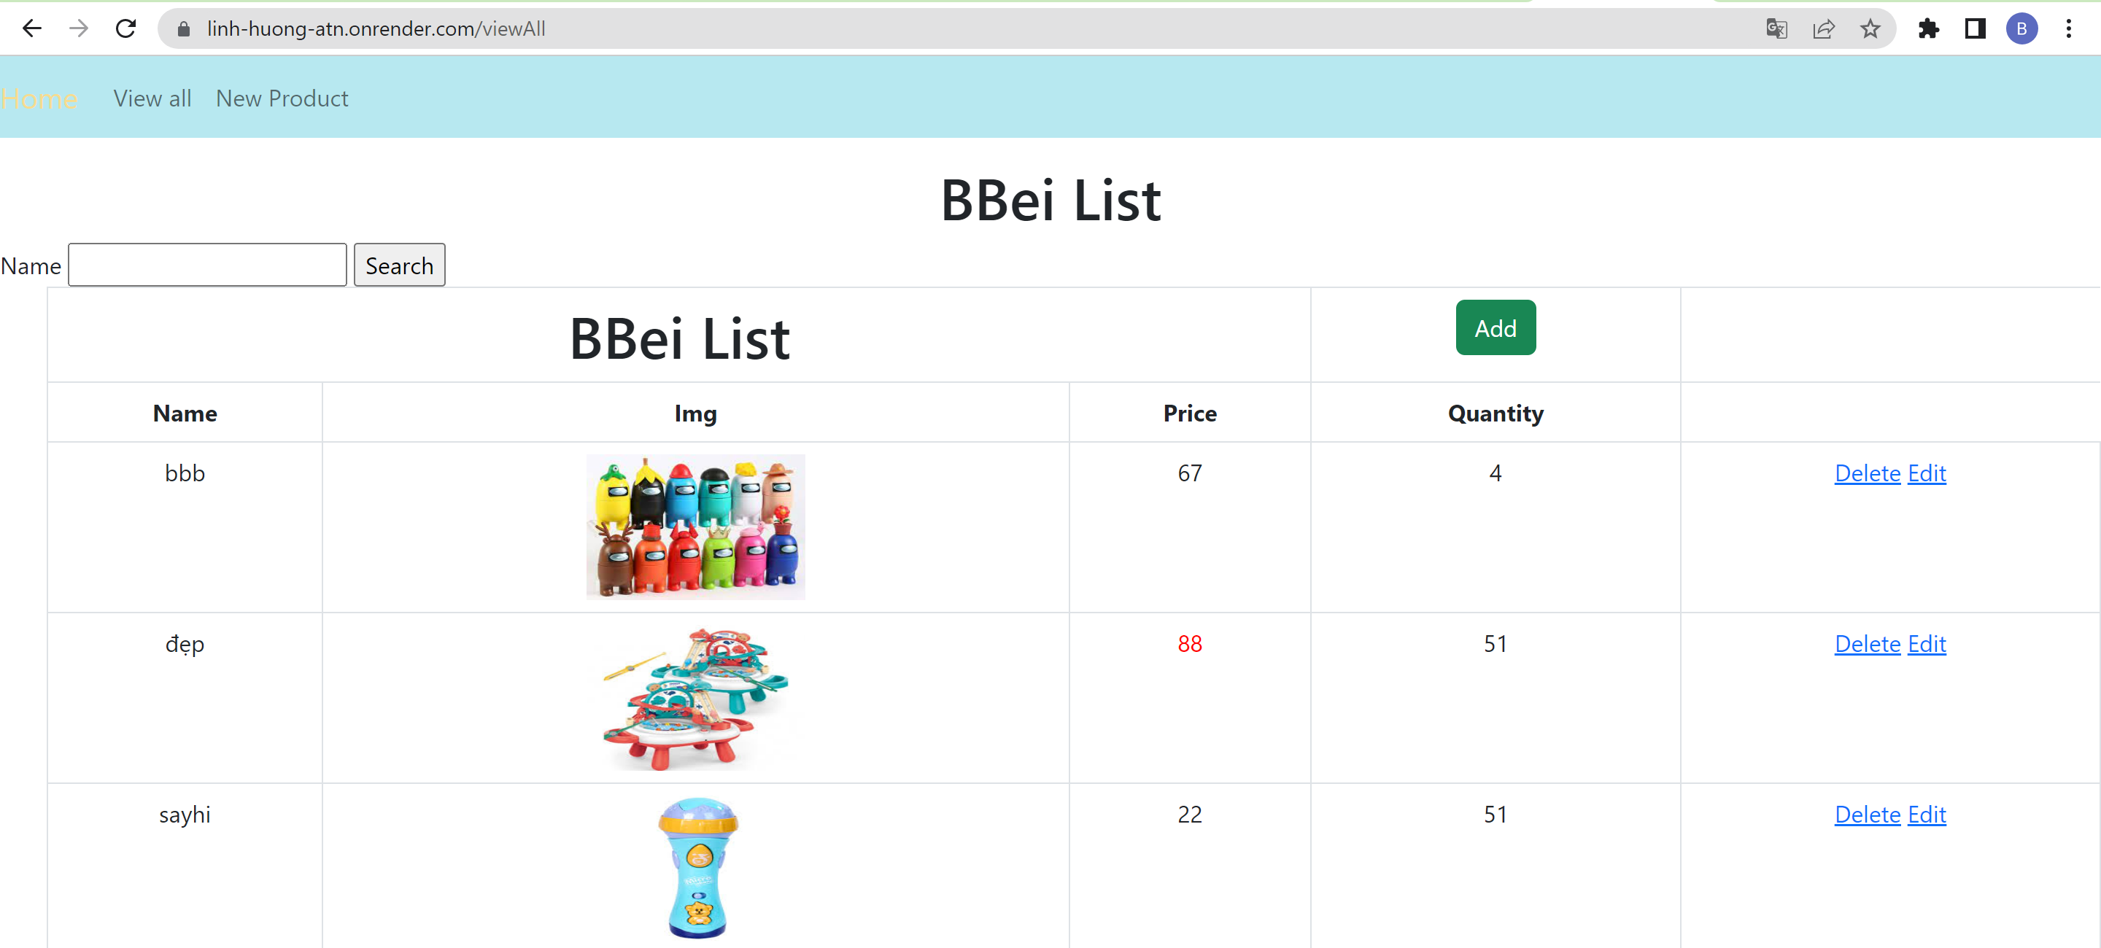

1. Source code and website

Source code: <https://github.com/linhbhgbh200662/Asm2.git>

Website: <https://linh-huong-atn.onrender.com>

# Task 2: Security

1. Analyze the most common problems which arise in a Cloud Computing platform and discuss appropriate solutions to these problems
2. Public cloud

Command Error This is not applicable when offloading to the public cloud. Outside of day-to-day operations, all configuration and other IT administration tasks are delegated to groups. Security is on the low side. Because data frequently shares a common location, it is not as secure as other cloud models. (Nayyar, 2019)

Solution: Choose reputable providers with a clear policy and a commitment to protecting your information and interests.

1. Private cloud

If your company's employees work away from the office, they may have trouble connecting to their private cloud and cannot securely access the programs, data, or files they need from the company's servers. Private clouds are subject to strict access controls. (Nayyar, 2019)

Solution:

Use a VPN. A VPN has two main advantages in this case:

* Enable your employees to securely connect to your company's cloud- and data center-based applications and data wherever they are.
* Authenticate customers and offer comprehensive, steady protection with out shopping luxurious hardware and community device or including IT complexity.

1. Hybrid cloud

Create a hybrid cloud by combining public and private clouds. As a result, every cloud has two issues. Aspects of technology and optimization should also be carefully considered. (Nayyar, 2019)

Solution: Developing a suitable model requires careful analysis of system size and usage. Depending on the size and scope of the system, the security and technical aspects of the system should be calculated to avoid technical errors and security glitches.

1. Access the most common security issues in cloud environments
2. Organizational security risk

The risk that can affect the operations and structure of the entire organization is referred to as organizational risk. Due to changes in service level agreements (SLAs), a CSP customer may be forced to switch to a CSP that better meets their needs. Damaged if CSP is closed or acquired by another company. Furthermore, your company may be vulnerable to malicious insiders who could use the data provided by CSC to harm you.

Solution: Malicious individuals are barred from joining the CSP team due to strict legal standards in employment contracts. This can be mitigated in part by obtaining a third-party evaluation of her CSP and establishing a trusted process for notifying users of security breaches.

(Aslan, 2012)

1. Physical security risk

An unauthorized person following an authorized person into a secure area is called tailgating. This inevitably happens when many people go through the door and only the first person is required to present an ID card or magnetic card. Easy to break into.

Worse.

Solution: Employee physical security training is one method of reducing tracking. This is less reliable, but much less expensive. Employee education and strict physical security policies must be implemented. B. Do not let strangers into your home. Employees should also be encouraged to notify security personnel as soon as they notice any changes.

(Aslan, 2012)

1. Data security risk

Social engineering techniques are frequently used by attackers to obtain personally identifiable information. Coercing or misleading anyone into disclosing personal information or providing access to a password-protected account is an example of this. One of these is phishing. Social engineering methods. This includes sending messages that appear to be from a legitimate source but were actually sent by an attacker. Malicious if the victim responds by providing personal information. These connections enable the attacker to infect the victim's device or gain access to the corporate network.

Solution: Identity-based Cloud Computing Layered Model (IBHMCC) and SSH Authentication Protocol are two authentication methods (SAP). This is done primarily for data security and confidentiality. IAM monitors three key aspects of security to ensure regulatory compliance: authentication, automated provisioning, and authorization services. OpenID, OAuth, SAML, and XACML are other technologies that support authentication, authorization, and access control services. TCG's IF-MAP standard employs authorized users and addresses other security concerns between cloud service providers and their customers.

(Tunggal, 2022)

# Conclusion

This journal will help you advance your knowledge of cloud computing, including basic ideas such as agility, networking, and cloud architecture. It also uses modern tools like express-nodejs and mongodb. Final products published on rendering platforms using PAAS models also use cloud computing. This article also discusses security issues that arise while building a cloud.

# References

Aslan, T., 2012. *Cloud physical security considerations.* [Online]   
Available at: https://www.ibm.com/blogs/cloud-computing/2012/02/22/cloud-physical-security-considerations/

Nayyar, 2019. *Handbook of Cloud Computing.* [Online]   
Available at: http://hero.lecturer.pens.ac.id/datahero/kuliah/cloud_computing/Handbook_of_Cloud_Computing.pdf

Tunggal, A. T., 2022. *What Are Cloud Leaks?.* [Online]   
Available at: https://www.upguard.com/blog/what-are-cloud-leaks